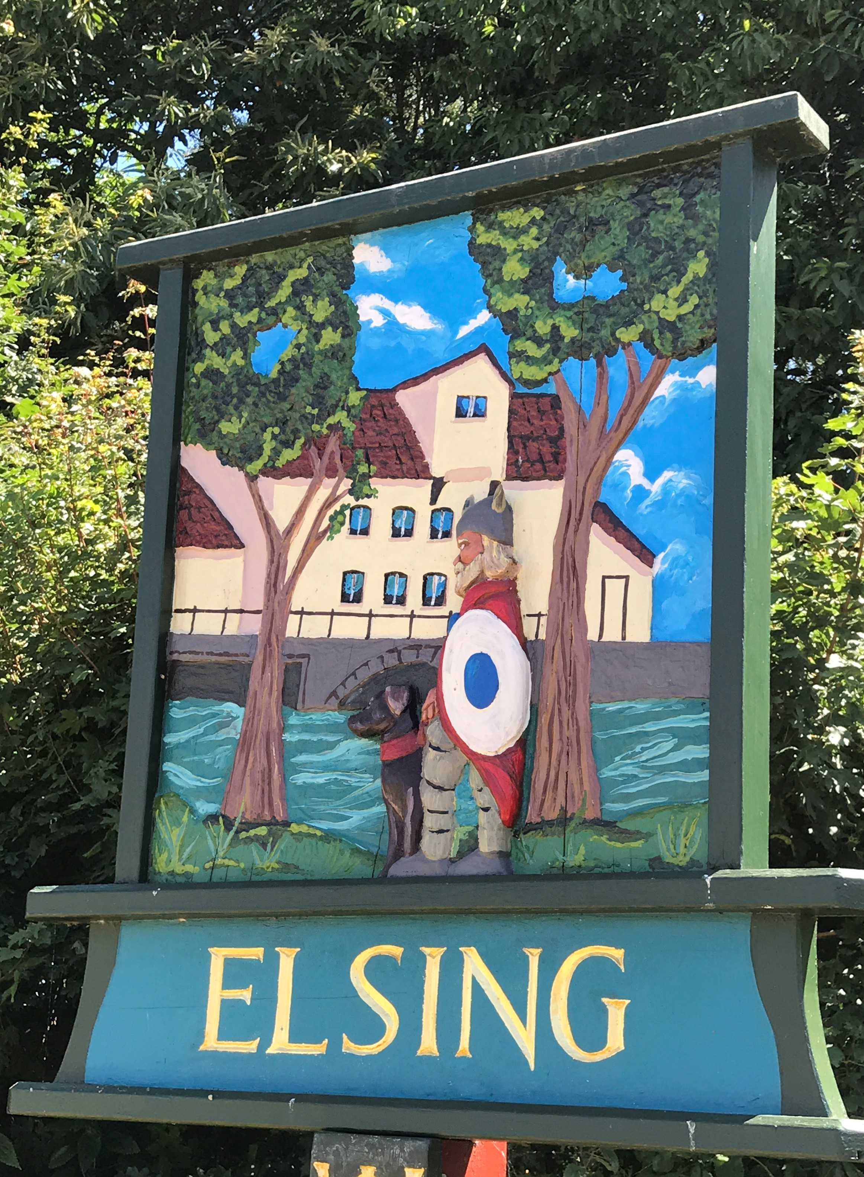
Elsing Parish Council

Annual Meeting Minutes
March 2019

Date of meeting: Monday 18 March 2019

Councillors Present: Pip Wallwork (Chair)
Henry Atkinson
Stuart Chaplin
Bill Horncastle
Suzy Horth (Clerk and RFO)
Oliver Laws
Terry Skipper

There were 8 members of the public in attendance

Item 1 - To receive apologies for absence – no apologies were received

Item 2 – Approve the minutes of the meeting held on 19 March 2018 - The meeting approved the minutes.

Item 3 – Matters arising – Ian Harris raised an issue around the requirement for resurfacing of the road along Peaseland Green. He felt that just chipping it, is not good enough as part of the road are subsiding. This is not just a surface issue. This causes a problem for lower suspension cars as this is creating a peak within the middle of the road from the debris left from farm vehicles. Mr Harris asked that the Parish Council lobby the District/County Council’s harder to ask that the foundations for the roads are looked at and full resurfacing to be considered. A full resurface has not taken place for 20-30 years and patching only has taken place. This road carries heavy farm traffic, which is causing some of the damage.

Henry Atkinson confirmed that he had met with Highways twice recently and had raised that the surface dressing may not solve all the issues. They had agreed to improve the drainage by digging out the ditches, and this had improved the drainage. Sadly due to this road being low use, it was felt that this may not be considered a priority within the Highways department. The meeting asked that the Clerk write to Highways formally to ask if foundation work would be considered, and make mention that it had been formally raised at the Annual meeting. The meeting confirmed that there was a lot of delivery traffic along this road and maybe a car count should take place, so that evidence could be presented to the council when making the request. The Chair will discuss with Mr Harris and propose a way forward.

The meeting also asked if there was any update on the missing Postbox from Peaseland Green. Oliver Laws confirmed that the Clerk had formally written to Dereham Post Office, but were yet to receive a response. The meeting confirmed that post box replacement is now covered by an outsourced company, so Oliver will find out the details and write to them direct to see if they respond.
Mr Harris also raised concern around hare coursing as he had come across some on the road towards Hall Lane. He called the police but they arrived too late. The Chair agreed to add a note to the next Parish Newsletter to raise awareness

Item 5 – Confirm date of next meeting - the meeting confirmed that the next Annual Parish meeting will take place on 16 March 2020 at 19:45 – to be followed by the Parish Council Meeting.

