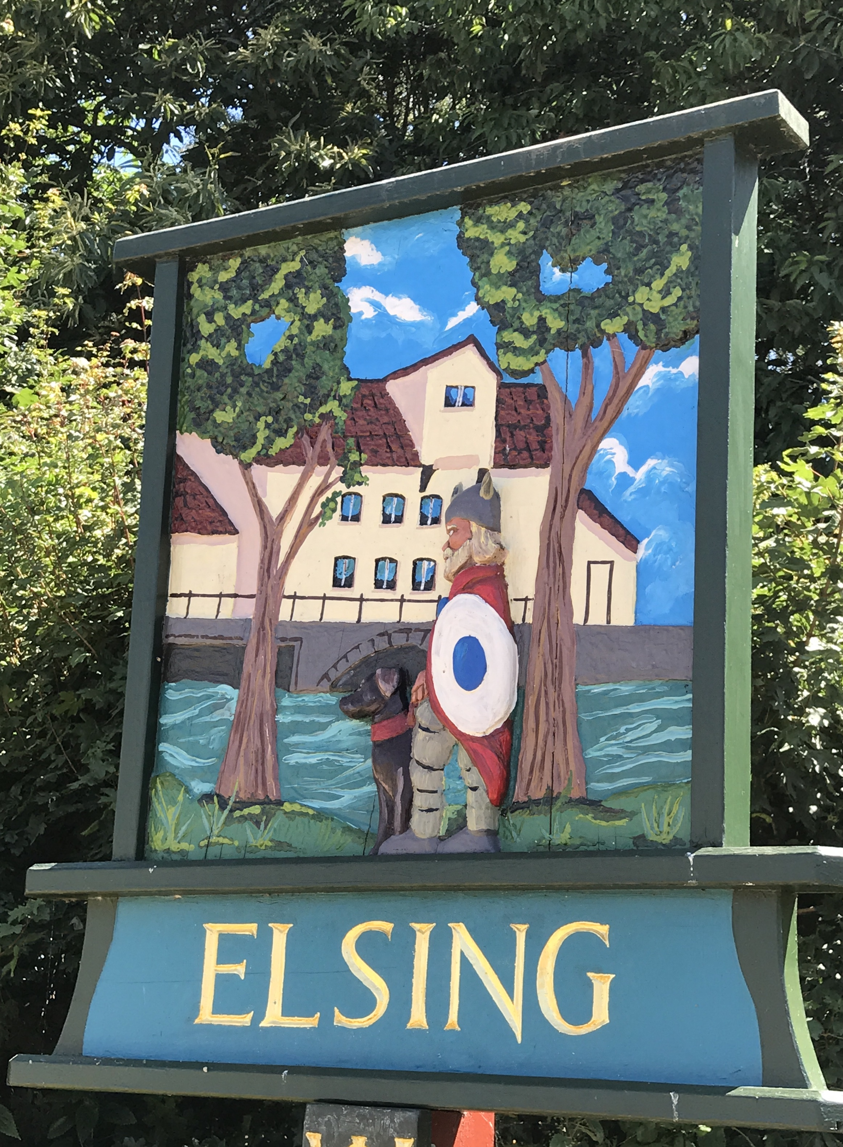
Annual Meeting Elsing Parish Council
Minutes

Date: Monday 13 May 2019
Time: 19:45
Place: Elsing Village Hall, Church Street, Elsing NR20 3EA

Before the meeting starts the Declaration of Acceptance of Office must be completed by the Chair and all councillors.

This was completed however as they were witnessed by other councillors, the Parish Clerk as the ‘Proper Officer’ must also sign them soonest.

Item 1 To receive apologies for absence - All councillors were present.

Item 2 Election of Chair - Pip Wallwork was elected as Chair

Item 3 Election of Vice Chair - Bill Horncastle was elected as Vice Chair

Item 4 Election of sub committee:

- Allotments - Bill Horncastle and Oliver were elected
- River Wensum sub committee – Stuart Chaplin was elected
- Footpath warden - Oliver Laws was elected

Item 5 Welcome to Steve Crebbin onto the council, and thank you to Terry Skipper.

The Chair extended a warm welcome to Steve Crebbin and a sincere thanks to Terry Skipper for his long term commitment to the Parish Council

