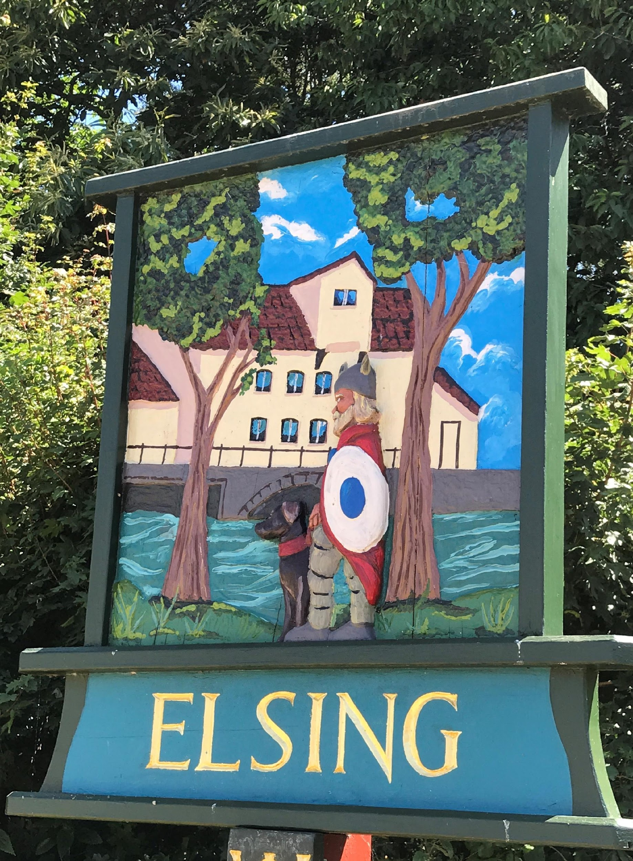
Elsing Parish Council

Meeting Minutes
July 2019
Date of meeting: Monday 15 July 2019

Councillors Present: Pip Wallwork (Chair)
Henry Atkinson
Steve Crebbin
Bill Horncastle
Oliver Laws
Stuart Chaplin
Suzy Horth (Clerk and RFO)

There were 5 members of the public in attendance

Item 1 - To receive apologies for absence – no apologies were received.

Item 2 The meeting approved minutes from meeting held on 13 May 2019 and 17 June 2019

Item 3 No declarations of interest in items or requests for dispensation were raised.

Item 4 Open Forum for Public Participation:

Pam informed the meeting that the local postman had sadly recently died unexpectedly. The chair suggested that a card/note be sent to offer condolences.

Action: Chair to write a note of condolence

The Chair confirmed that Item 10 Missing Peaseland Green Postbox update should be moved up the agenda. Cllr Laws confirmed that he had received correspondence from the post office, confirming that they would not proceed with his request to replace the missing post box. The meeting discussed the best way forward and Cllr Laws will formally write back to ask that this postbox is replaced, together with a template letter for all affected residents to sign so that they can send a letter, to increase the volume of contact received about this.

Action: Cllr Laws to write a letter to the post office, and draft a template letter and send round to affected residents so they can send direct.

Cllr Bambridge updated the meeting and confirmed that the Breckland Local Plan has now been completed by the inspector. The inspector has the first week of August to make any changes to this ahead of this being submitted in early August to the Council, for approval at their September Council meeting.

Cllr Bambridge also confirmed that the Council had recently purchased a property within the Thetford area as emergency housing for homeless families within the district. He confirmed that the property could house up to 20 family units. There is a similar property within Dereham. He confirmed that this will save the Council between £140-£200k per annum on funding for bed and breakfast accommodation.

Cllr Banbridge also confirmed that the Council had formal approved Option C for the NDR route. Cllr Bambridge confirmed that he was commenting against this, as he felt Option D, as previously favoured should be the preferred option, due to Option C being a long route, this links to the Bury Lane/Wood Lane junction, which had previously been noted around the difficulties this junction could cause, and it has no direct link to the Hubs.

Item 5 Annual Governance and Accountability Return (AGAR) update – the clerk confirmed that this had been signed off at the meeting in June and completed. The certificate of exemption has been submitted to confirm that our income is less than £25k and published on our website.

Item 6 Internal Audit update – the clerk confirmed that she had met with the auditor to confirm the process. The auditor has completed her section of AGAR and signed this off with no actions required.

Item 7 Correspondence – letter from Scotty’s Litte Hero’s - The council has received a letter from Scotty’s Little Heros from Kings Lynn seeking support from the council. The meeting discussed this and agreed that further research was required to establish further information about this charity. This will also be added to the March agenda, when budgets are set for discussion.

Action: Clerk to contact Scotty’s Little Hero’s to confirm that this will be tabled at the March budget setting meeting for discussion.

Item 8 update on co-option of 7th Councillor, and agreement of wording for advert inviting villagers to become a Parish Councillor. – The Chair confirmed that this had recently been advertised, so planned to go for a “light touch” advert within the newsletter and asked that all Councillors be available to speak to anyone who may be interested.

Action: Chair to add to the newsletter.

Item 9 Agreement to apply for a grant on behalf of the Elsing Heritage Society to fund leaflets to show walks around Elsing. – the meeting agreed that Cllr Laws look into this and make an application as required.

Action: Cllr Laws to progress an application for a grant.

Item 10 Missing Peaseland Green Postbox update – taken earlier in the meeting

Item 11 Update on Well (Bore Hole) project – Cllrs Horncastle and Laws confirmed that this was now being progressed as a “Well”. They have got a copy of how to dig a well from Water Aid, which will help. They will also need to purchase concrete reams to line the Well. The meeting agreed that further costing would need to be pulled together, alongside a Health and Safety Risk Assessment. The meeting discussed whether a grant could be applied for. This will need to be considered, alongside any other grants we look to apply for.

Action: Cllrs Horncastle and Laws, to progress costings, and looking into getting a risk assessment done/professional advise around the health and safety elements.

Item 12 To consider any planning applications – no planning applications were received.

Item 13 Footpath/Allotment Update – including update on proposed Pig Pen – Cllr Laws updated the meeting. This has now been cleared by a digger (invoice for £200 = VAT (£40) to be paid. Cllr Laws confirmed that J Fencing from Dereham had donated the stock fencing and posts and asked that thanks be given in the next newsletter.

Cllr Laws also confirmed that he is on top of the admin around the allotment holder getting a holding number to enable them to keep pigs.

The footpath alongside the Church is over grown and Cllr Laws confirmed that he would contact the Norwich Diocese to ask that this is attended to.

Cllr Laws confirmed that the orchard is looking good and has been recently cut. 2 of the 3 trees planted last year have taken and are doing well.

There are also 2 allotment plots available to rent and the Chair will advertise these in the next newsletter.

Action: Chair to add to the newsletter. Cllr Laws to contact Norwich Diocese around the over grown pathway.

Item 14 Highways Update
- 7.5t environmental weight restriction in Lyng and surrounding areas – including proposal to formally invite Jonathan Taylor from Norfolk Highways to an open meeting in Elsing. Cllr Atkinson updated the meeting and confirmed that an open meeting should take place for residents. The Clerk confirmed that contact has been made with Highways and a chasing email has been sent.

- Potentially dangerous tree on Heath Road - Cllr Atkinson updated the meeting and confirmed that this has now been dealt with.

- Other update – Cllr Atkinson confirmed that he was in contact with Highways and the promised works would be completed within August. The meeting noted that some of the pot holes had been attended to.

Item 15 Defibrillator Boxes – consideration of maintenance costs
(high visibility stickers £96.00, K6 paint £40.00 and labour costs)

The meeting discussed this. It was agreed that the purchase of the glass signs and paint be undertaken. The Chair and Cllr Horncastle will review the paint requirements before purchasing. A note will then be put in the newsletter to make this a community event to get them painted.

Action: Chair and Cllr Horncastle to discuss paint costs and then notice to be added to newsletters to organise a “community” paint of the telephone boxes.

Item 16 Financial update from Clerk

- Inclusion of budget figures in monthly spreadsheet – the meeting discussed the proposed spreadsheet which Cllr Horncastle was proposing. The meeting agreed that all to review all spreadsheets and confirm “what” it is they want from them, to avoid duplication. All comments to the Clerk and this to be agreed at the September meeting. The meeting also discussed the need for 2 bank accounts and again a decision on the way forward to be made at September meeting.

Action: All to review budget sheet and decision “what” it is they require from it, so this can be agreed in September. All comments back to the clerk as soon as possible.

The clerk updated the meeting to confirm:

Business premium account balance: £5,330.44

Community account balance: £307.00

Monies received:

VAT reimbursement: £727.97

Claims this month:

Clerk expenses claim: Clerk expenses £98.09

Electricity (July) £10.00

TOTAL CLAIM £108.09

The meeting approved this claim.

The meeting closed at 21:15

To confirm date and Time of Next Meeting: 16 Sept 2019 2019, 7.45 in the Village Hall.

