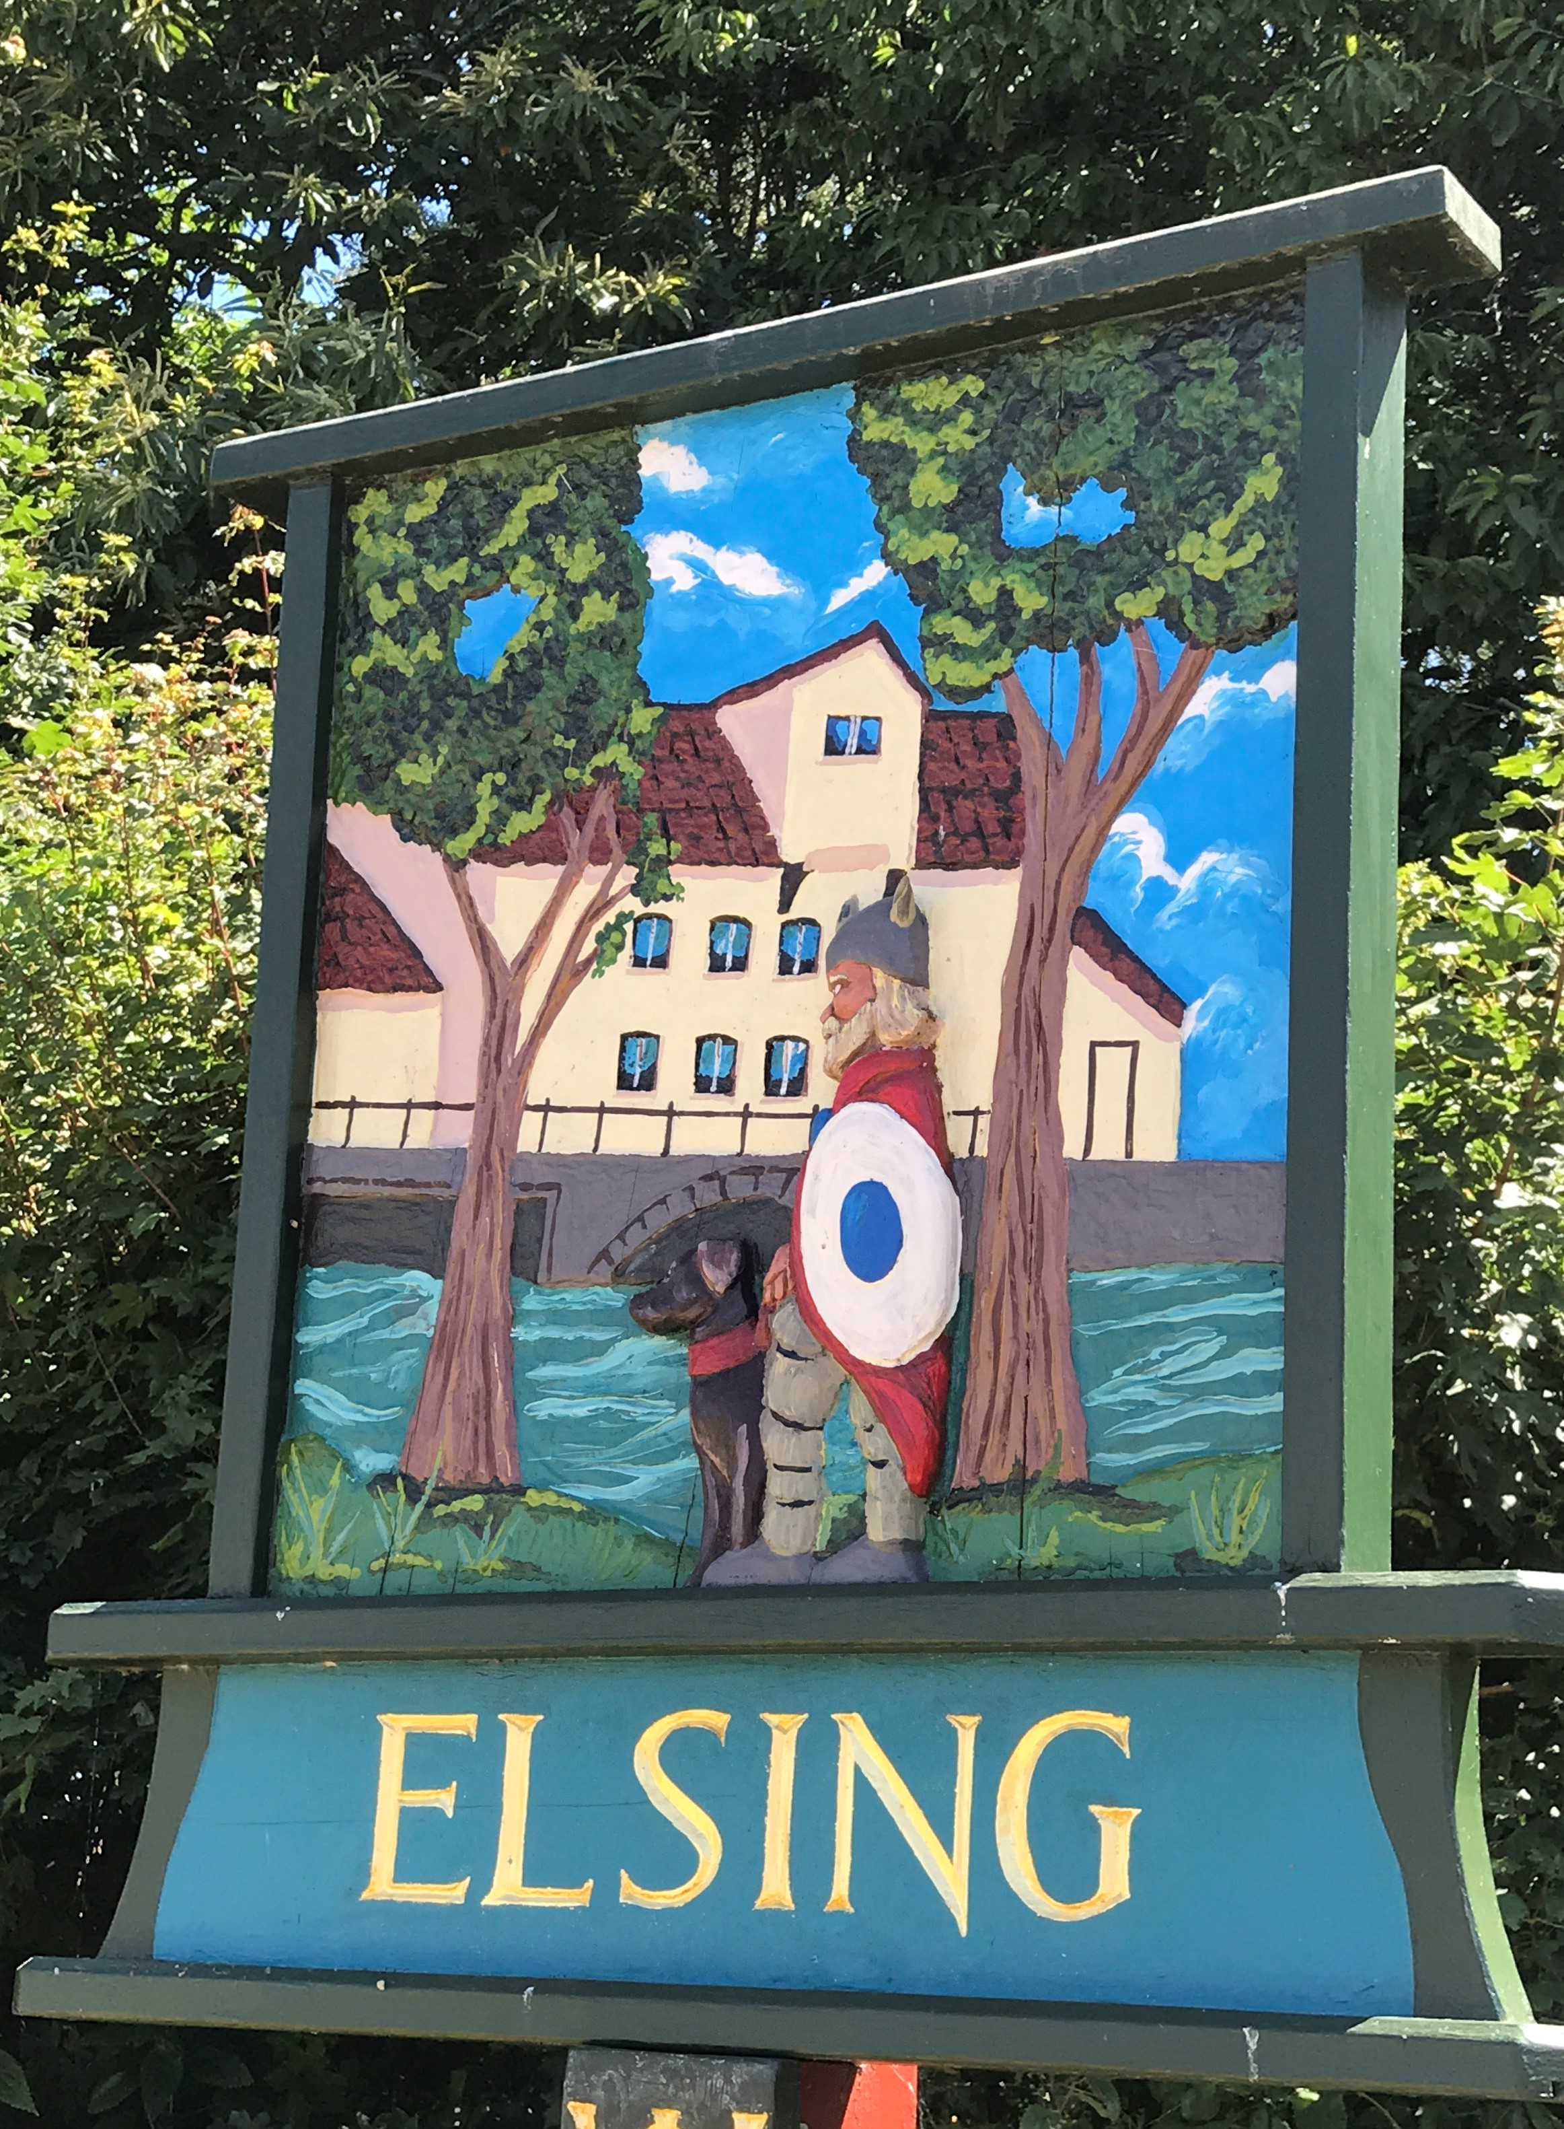
Elsing Parish Council

Meeting Minutes
March 2019

Date of meeting: Monday 18 March 2019

Councillors Present: Pip Wallwork (Chair)
Henry Atkinson
Stuart Chaplin
Bill Horncastle
Suzy Horth (Clerk and RFO)
Oliver Laws
Terry Skipper

There were 8 members of the public in attendance

Item 1 - To receive apologies for absence – no apologies were received

Item 2 – Declaration of interest - no declaration of interest or request for dispensation were raised for any items on the agenda.

Item 3 – Approve the minutes of the meeting held on 21 January 2019 - The meeting approved the minutes as a true record of the meeting.

Item 4 – Open Forum - all items were raised in the Annual Parish meeting, so nothing further was raised.

Item 5 – Forthcoming elections update - the Clerk gave a reminder of the key dates that had been published within the recent Newsletter and will provide regular updates as the process unfolds. The chair asked if it was felt useful for any prospective candidates to write a short biography so that these could be published to help inform the parish. All councillors agreed to send over a short biography to the Chair for publication once all candidates had been confirmed for publications within the parish newsletter.

Item 6 – Elsing Church funding request - The chair confirmed that she had been approached by the Church for assistance with funds for the car park. Historically the Parish have donated funds equally to the Village Hall and Church (for non-church activities). The chair and Henry Atkinson hold an annual quiz to help raise funds for the church and maintenance and this raises a substantial amount. The meeting agreed to send the annual funds of £400 for the Church and the same to the village Hall together with the quiz proceeds going to the church. The Clerk will write and confirm this to the Church and Hall.

Item 7 - Charity Commission update The chair asked that this item be deferred until the next meeting to enable a charity commission meeting to take place so discussion could take place. Clerk to set up meetings to discuss this.

Item 8 – Peaseland Green Post box - this was covered within the Annual meeting.

Item 9 – Planning Applications - there were no planning applications to consider on this occasion.

Item 10 – Footpath/Allotments/Boreholte updates - Oliver Laws provided an update on the Bore Hole project. He has been lent a pump to empty his well, so they can test how quickly this will re-fill. If this is ok, then they will consider a shallow well at the allotment and this would be a cheaper option.

Footpaths – Elsing Heritage Society would like to create a leaflet of walks showing maps, etc around Elsing all of which will start at the church and wondered if the Parish Council wishes to be involved? Neighbouring parishes have undertaken something similar. Oliver explained that we can gain access to Ordnance Survey maps free of charge as a Parish, so he will look at how to sign up for this. Oliver will also look into whether we can consider apply for a Norfolk Community Foundation Scheme grant to pay for the printing, etc. The meeting confirmed that this could be considered a joint venture.

Allotments – Oliver confirmed that these are now all let out. There had been some break-in’s but nothing much was stolen.

Pig Pen – Oliver had produced a report detailing the proposed costings. The main cost is around the levelling of the ground and this would require the hire of a digger. They have a prospective tenant who would be interested and would be happy to do the fencing themselves, with Bill Horncastle and Oliver over seeing any works. Bill confirmed that they would look to produce a contract which would cover everyone legally. The meeting approved the £200 spend for the digger to enable to land to be levelled. All other costs to come from the allotment budget/income. The allotment budget had been approved as part of the last meeting budget setting.

Litter Pick – Oliver confirmed that the litter pick had been successful. The meeting agreed that this would be tabled at the meeting next January to ensure it was formally voted on and to ensure dates were suitable for all those who wished to take part. The meeting asked if Peaseland Green and Mill Street could be included in the litter pick and week day and weekend dates be offered.

Item 11 – Highways update - Henry Atkinson confirmed that the council had been round and flagged with white paint any pot holes/damage to be repaired. Henry confirmed that he had reported some pot holes on Back Lane and confirmed that anyone can do this by going direct to the council website.

Bill Horncastle confirmed not much progress had been made around the NDR link Road. Of the options presented option D is looking to be the most popular. Bill will display the paperwork on the Village Board noticeboard.

Item 12 – Financial update - the following financial update was given by the Clerk:

Business premium account balance: £4,948.16

Community account balance: £236.78

Total monies available: £5,184.94

Claims this month:

Norfolk Parish Training and Support (NPTS)
Yearly subscription 19/20 £35.00

Clerk Fees: £166.95

The meeting approved these costs and accounts.

The meeting closed at 21:00

Date of next meeting: Monday 20 May 2019 – 19:45 – Annual meeting to be followed by Parish Council Meetng)

