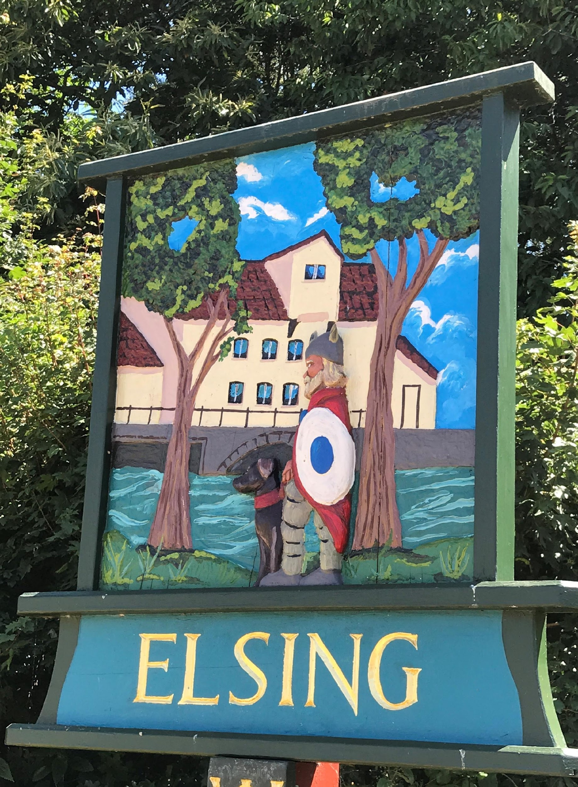
Elsing Parish Council

Meeting Minutes
May 2019

Date of meeting: Monday May 13th 2019

Councillors Present: Pip Wallwork (Chair)
Henry Atkinson
Stuart Chaplin
Steve Crebbin
Bill Horncastle
Oliver Laws

There were 6 members of the public in attendance

Item 1 - To receive apologies for absence – apologies were received from the Clerk.

Item 2 – Declaration of interest - no declaration of interest or request for dispensation were raised for any items on the agenda.

Item 3 – Approve the minutes of the Annual Meeting and Parish Council Meeting held on 19th March 2019 - The meeting approved the minutes as a true record of the meeting.

Item 4 – Open Forum - Annette Wearmouth described how she had contacted the Royal Mail head office in Norwich and Breckland Council (Louisa) re the missing postbox at Peaseland Green. It is not clear whether it will be replaced or not. Annette to be contacted by the Royal Mail within the next 10 days for an update. If no progress is made by this time members of the Parish Council and affected Villagers will be given contact details in order for them to ring and make it clear how important it is to replace the missing Mailbox.

Gordon Bainbridge (District Councillor) explained that Breckland grants/funding would be directed predominantly at Market towns in the area, of which Dereham is one. Grants/Match funding will still be available to Parish Councils via the Norfolk Community Trust.

Steve Crebbin raised the possibility of asking Elsing Villagers what extra amenities they would like to see in the Village for which it might be possible to obtain a grant. Pip Wallwork and Steve Crebbin to discuss further.

Item 5 – Annual Governance and Accountability Return (AGAR) This was not discussed in any detail because the meeting had been brought forward a week (because 3 of the councillors were unable to attend on the original meeting date) and Parish Clerk was unable to attend this the rescheduled meeting. The Chair and the Clerk are meeting on Friday 17th May to complete the AGAR and arrange audit details etc.

Item 6 – Internal Audit Update. See item 5 above.

Item 7 - Future meeting dates and frequency The possibility of holding monthly meeting was discussed and rejected. Instead it was agreed that if the Council agreed that an extra meeting was required at any time an extra meeting would be scheduled.

The bi monthly meeting dates are: 15 July 2019, 19 September 2019, 21 October v2019, 16 December 2019, 17 February 2020, 20 April 2020 and 18 May 2020.

Meetings will be held in the Village Hall starting at 19.45.

Item 8 - Consider advertising for co-option of 7th Councillor It was agreed to include an article in the Village Newsletter describing the vacancy/co-option process, and asking any interested parties to apply. PIp Wallwork to compile article and email to Councillors for comment prior to including in a newsletter.

Item 9 – Peaseland Green Post box - see item 4.

Item 10 – Update on Bore Hole project - Oliver Laws and BIll Horncastle carried out tests on Oliver’s well and have concluded that a similar depth hole will satisfy allotment requirements. The hole will be dug using a JCB the resulting chamber will have to be lined and a mechanism for extracting the water installed. Jo Yates will be responsible for compiling details/costs, identifying any health and safety issues and contacting suppliers. It may be necessary for the Parish Council to apply for a grant to fund the work.
.
Item 11 – To consider any planning applications - There were no planning applications to consider on this occasion.

Item 12 – Footpath/Allotment Update, including update on proposed Pig Pen - Allotment rents (|£511.50) have been received and passed to Pip Wallwork to hand on to the Suzy Horth at the Friday 17 May meeting for banking. There are still 2 vacant allotments Pip Wallwork to include another ad in the next Newsletter. A digger is going to flatten the ground in the pig pen in early June.

Item 13 - Highways Update- There is a tree on Heath Road (Grid reference 058171, on the south side of Heath Road, just past the old chapel going north-eastwards) which leaning over to a potentially dangerous extent. It is unclear whether it belongs to David Baker or whether it is the responsibility of Norfolk Count Council. Oliver Laws has emailed David Baker to see if he is responsible for it. It was agreed that the Clerk write to NCC on behalf of the Council if It seems to be their responsibility, to have the tree made safe. Henry Atkinson to help Suzy Horth draft a letter to the council.

Link Road - Bill Horncastle updated the Council - Option D is the preferred option, the final decision will be made in July.

Proposed 7.5t Environmental Weight Restriction in Lyng and the Surrounding Area. Henry Atkinson proposed that we object to the proposal (by June 10th) requesting that the boundary be extended to include all of Elsing including Peaseland Green. The clerk to write a formal rejection on behalf of the Parish Council.

Update on road repairs within the Village - the road by Green Farm has been repaired and it is anticipated that Peaseland Green Road will be surface dressed throughout the end of the summer.

Item 14 - Defibrillator Boxes - consideration of maintenance costs (high visibility stickers £96.00, K6 paint £40.00 and labour costs) - Stuart Chaplin proposed that the 6 ‘telephone’ glass inserts in the top of the 2 telephone boxes be replaced with ‘Defibrillator’ inserts and that each box should be repainted using K6 paint. All of this is available from www.x2connect.com.

Costs:
K6 refinish gloss paint, 2.5 litres 40.08 excl. VAT and delivery
K6 pink primer paint, 2.5 litres 32.85 excl. VAT and delivery
K6 gloss repair paint 500 ml 13.33 excl. VAT and delivery
6 Defibrillator signs @ 20.30 each 121.80 excl. VAT and delivery

Total so far: 208.06 excl. VAT and delivery. Still to be added are labour costs (currently being investigated) by the Parish Clerk.

Item 15 - Financial Update from the Clerk
Business premium account balance: £5,383.72
Community account balance: £234.83
Total monies available: £5,618.55

Claims this month:

Incoming payment

Recycling Payment – Breckland DC £116.12

Proposed expenditure:

Community Car Scheme – P D Clough £150.00
Public Liability Insurance – Zurich £387.20
Annual Subscription – Norfolk Assoc of Local Councils £139.20

Total £676.40

Clerk expenses claim: Clerk expenses 186.37

Electricity (April and May) £20.00

TOTAL CLAIM 206.37

Total Expenditure this period: 882.77

The expenditure was sanctioned.

Bill Horncastle requested a more detailed breakdown of the Clerks expenses.

To confirm date and Time of Next Meeting: July 15th 2019, 7.45 in the Village Hall.

