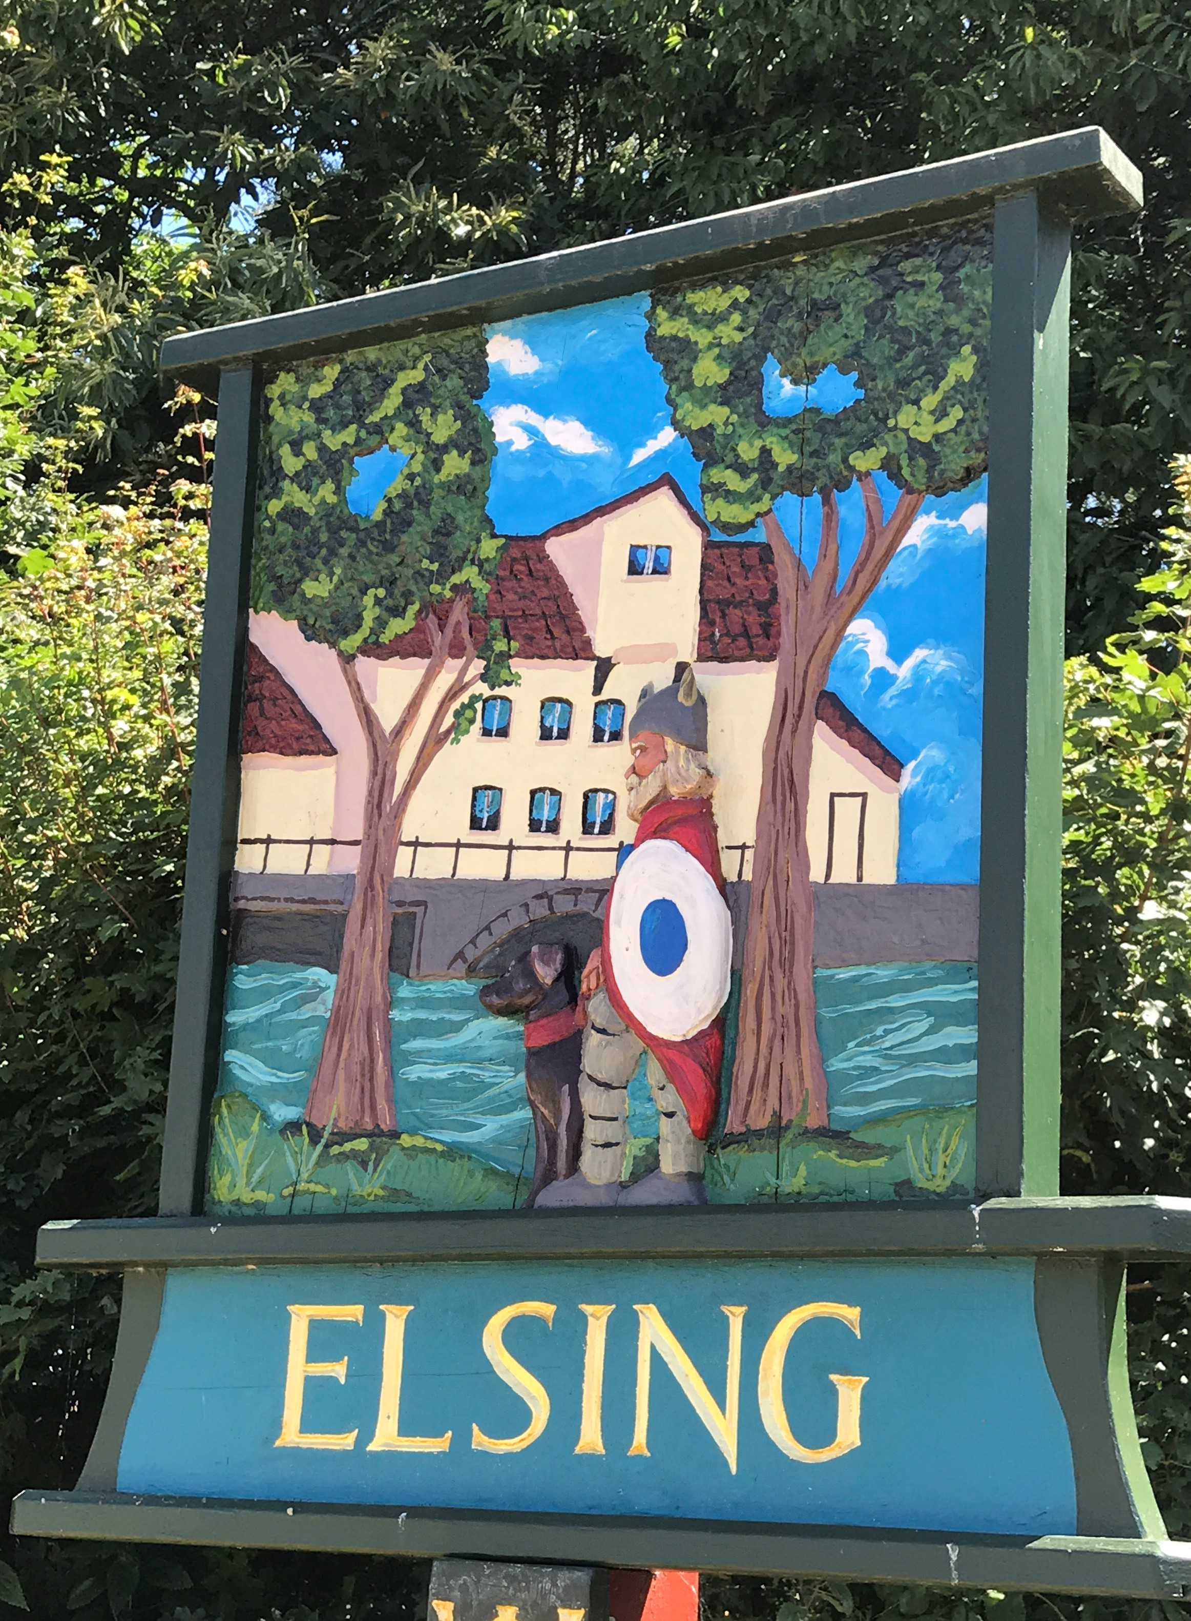
Elsing Parish Council

Meeting Minutes
January 2018

Date of meeting: Monday 21 January 2018

Councillors Present: Pip Wallwork (Chair)
Henry Atkinson
Stuart Chaplin
Bill Horncastle
Suzy Horth (Clerk and RFO)
Oliver Laws

There were 8 members of the public in attendance

Item 1 - To receive apologies for absence – apologies were received from Terry Skipper.

Item 2 - To receive declarations of interest on items on the agenda and requests for dispensation – no declarations were raised.

Item 3 – To approve the minutes of the meetings held on 19 November and 3 December 2018 - The meeting approved the minutes, save for the amount of precept being approved to be added to the December minutes.

Item 4 – Open Forum for Public Participation – nothing was raised by the public. Oliver Laws gave an update on the Bore Hole project. Joanne Yates continues to work with Oliver and they have been in contact with the suppliers about making a shallow well. They advised that they test the nearest well, by emptying it, and recording how long it takes to refill. They are not looking for any funding at the current time, as they haven’t confirmed what works will be required. They are considering doing this as a possible DIY project but will keep the council updated.

Item 5 – Agree draft Financial Regulations – the meeting approved the Financial Regulations, save for the addition of the risk assessment, which will be added and recirculated.

Item 6 – Agree draft Budget/Precept- the meeting had discussed the budget, which had been covered in detail at the December meeting and approved the budget and request for precept of £2,866. A request has been received for funding to assist with the lawn maintenance at the church and this will be added to the March agenda for discussion.

Item 7 – Resignation of Councillor and forthcoming Elections – the meeting noted that Councillor Jones had submitted his resignation. The meeting confirmed that they would not look to co-opt onto the council, due to up and coming elections in May, and there being only 1 further meeting ahead of the elections. The Clerk updated the meeting on the process for applying to become a councillor and details will be made available and can be found on the Breckland District Council website. Publication of notices of election will be displayed before 26 March, with the deadline for delivery of any nominations forms to Breckland District Council by 16:00 on 3 April. The Chair confirmed that the timetable will be added to the next Parish newsletter.

Item 8 – Former Highway Surveyor’ Land update – Henry Atkinson handed round a copy of a plan which showed the 1 acre of land at the bottom of Heath Road. The Charity Commission had written to comment on the state of the land. There is a charity account which is linked to this land with a balance of £1,943 (£2.58 of which is interest). As a Parish Council we are trustees of this account. There is no defined boundary. The money came from the sale of a strip of the land.

This was highlighted as it is an asset to the village which is currently not being utilised. The meeting agreed to add this to the March agenda for discussion, and arrange a trustees meeting. The Clerk to then update the charity commission.

Item 9 – Missing Peaseland Green Postbox update – Oliver Laws updated the meeting. He confirmed that he had written to the Post Office and the Post Master at Dereham. He had received a reply to confirm that they were aware that it was missing, but did not answer his question about when this would be replaced. Oliver Laws will make further contact and report back.

Item 10 – to consider any planning applications – there were no planning applications to consider.

Item 11 – Footpath/Allotment update – Oliver Laws updated the meeting and confirmed that 2 allotments had become free. Contact had been made from a member of the public and Oliver had been in contact to arrange a discussion. There had been a number of break ins on the allotments, but not much had been stolen.

Oliver Laws and Bill Horncastle raised about the spare land which sits at the back of the allotments (by the vegetable garden). The land is approx. 330 square metres, it’s a long strip of land which is tree lined and they were looking at options to use this land in a more productive way. The area is strimmed, but the ground is very uneven. Consideration was being given to making this into a pig pen that would be rented out. They would need to purchase fencing, a pig arc and gate. The plan would be that the rent would look to cover the investment over a period of time. The meeting agreed that Oliver Laws and Bill Horncastle would produce more definitive figures of costs and plan for pay back for consideration at the March meeting.

There was nothing further to add on footpaths.

Item 12 – Highways update

- Henry Atkinson updated the meeting and confirmed that he and Annette had recently met with John Cotton from Norfolk Highways. They had identified improvements/enhancements which were a combination of the removal of debris present in the upstream ditch which is in need of urgent cleaning, together with making more effective the two road gullies. Together they are failing to direct all the run-off surface water in the main drain which is critical for the system to function.

They also agreed that “apron” kerb arrangements and the “sandbag” headwall will be provided at the existing gullies and the entry point of the carrier drain to enable the capture of water into the drainage system.

Regarding the flooding site nearly opposite Green Farm entrance they have agreed to build up a 20m section of the north side of the road to aid run-off along an existing nearby field pond. This work will be done in the summer, prior to the surface dressing of the whole length of the Peaseland Green Road (which was already in the Summer Programme of works planned).

Stuart Chaplin asked if there had been any update on the speed camera. The Chair confirmed that she had been in contact with the Council and local parents. The issue arises mainly in the summer holidays and the Chair confirmed she was looking into a more “professional” sign which could be put out in the summer holidays to make drivers aware, that was not permanent.

- Bill Horncastle confirmed that contact had been made with Highways, and they had confirmed that the signs would be removed. On checking today, ahead of the meeting, they were still there. The meeting agreed that if the signs remained in a weeks time that the Clerk should write to Highways to confirm that the Parish Council would remove them and store them safely.

- The chair confirmed that there will be a temporary closure of Heath Road whilst repairs to the overhead BT cables are done between 28-29 January. The Clerk confirmed that this was between the hours of 09:30 and 15:30, and signs had been placed on the roadside to notify residents.

Item 13 – Funding request for replacement dog bin opposite village hall Henry Atkinson confirmed that the lock on the dog bin opposite the village hall had broken and requested funding to replace with a new one. The meeting requested that the Clerk look at when this was purchased, as it was felt we may be able to go back to the manufacturers.

Item 14 – Financial update from Clerk – the Clerk provided the following update:

Business premium account balance: £5,245.64

Community account balance: £248.94

Total monies available: £5,494.58

Claims this month:

Parish Clerk preparing for elections training £28.00

Clerk Fees: £284.16

The meeting approved these and the Clerk will ensure payments are made. The Chair confirmed that the Clerk fees were slightly higher than normal due the Clerk being new in role and undertaking training, and the extra meeting to agree and submit the Budget.

Meeting closed at 21:00

Date of next meeting: Monday 18 March 2019 (Annual Parish meeting to be followed by Parish Council Meeting) at 19:45, Elsing Village Hall

Signed.................................................................Chair................................................Date

