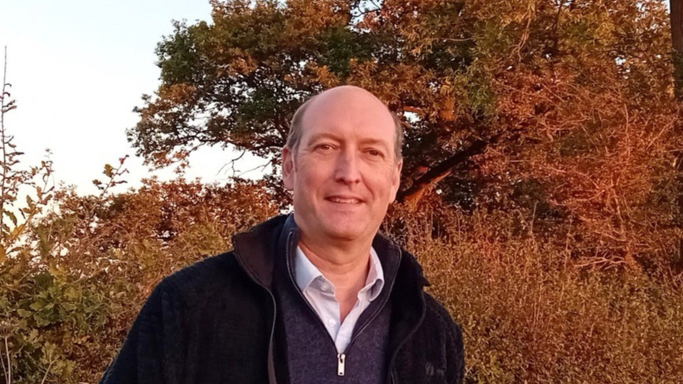

Cllr BILL BORRETT
Parish report for the Elmham and Mattishall Division
February 2025

Postponement of Elections and Local Government Reorganisation
This week the Government announced that the County Council Elections due in May are to be postponed for a year to facilitate the re organisation of Local Government in Norfolk and Suffolk.
I campaigned for the elections to go ahead as planned but was unsuccessful in getting the Government to listen. I am sure those who would have been elected would have opposed the new plans.
Norfolk and Suffolk are to have a joint Mayor who may well be based out of the County, who will have very little accountability to residents. They will also cover their costs, and that of any plans that they might have, by charging a precept (tax) which will be added to your Council Tax bill.
The second stage is the abolition of all the District Councils such as Breckland and the County Council. This will mean a huge increase in Council Tax here in Breckland. This is because we have the lowest District Council tax in the Country and all the rates will have to be equalled out across the new Councils. Those Councils in Norfolk with higher Council taxes will be reduced and the lower ones increased, to make a new average charge. It is worth noting that this increase will not result in any enhancement of services provided. Breckland also has no debt and the debt of the other Councils will be shared out across the new Councils.
We can still make our voices heard as the legislation has yet to go through Parliament and I understand that a consultation will be launched shortly. I will make sure that you all get details on how to take part.
If you disagree with the approach that I am taking please let me know, as I am trying to represent your views and I don’t want to be out of step.

Working Well Norfolk helping people with long-term health issues to keep working
A scheme to support people in Norfolk with long-term health issues get back into employment or continue in their jobs has already helped more than 1,100 participants.
The Working Well Norfolk programme, launched in October 2023, supports individuals with long-term health issues to return to or stay in work. It has already helped over 1,100 participants, with 200 moving into work and 150 staying employed despite health challenges. The programme has received 1,600 referrals and will continue for another 18 months, with additional funding to help 730 more people, totalling 1,830 participants by September 2026. The £5.2m project is managed by Norfolk County Council and delivered by Seetec Pluss and Standguide Ltd. For more info or to refer, visit Working Well Norfolk - Seetec Pluss or call 01603 561054.

500,000 trees planted as part of 1 Million Trees for Norfolk scheme
Norfolk County Council has reached the halfway point of its 1 Million Trees for Norfolk initiative, planting the 500,000th tree. The milestone tree, a Norfolk Oak, was planted at Priscilla Bacon Lodge with support from Paul Bussey, who has funded several tree planting projects. Grown by volunteers at Gressenhall Community tree nursery, the tree is part of the scheme launched in 2020 to plant one million trees across the county. The project has engaged local communities, schools, businesses, and landowners, with the council aiming to plant 150,000 trees annually until the goal is achieved.

Get hands-on with technology at your local library throughout February
DigiFest is an annual celebration of digital creativity held across Norfolk libraries throughout February, offering free events for children and young people up to age 16. The festival, part of Norfolk County Council's digital inclusion strategy, aims to inspire the next generation of coders and creators by helping hundreds of children develop new skills, boost confidence, and have fun.
Over 100 free events will take place in 47 libraries across Norfolk, including activities like stop-motion animation, basic coding with robots, and 3D pen creations. Special sessions include Lego™ robotics with ICT Solutions, cyber security escape rooms in Thetford and Great Yarmouth, and a virtual reality workshop in Norwich hosted by UST.
DigiFest runs from February 1-28, with many events scheduled during half-term week. All events are free, but pre-booking is required for most. For more information, visit www.norfolk.gov.uk/digifest

Made Smarter to boost region's manufacturing and engineering sector
Advanced manufacturing and engineering SMEs in the East of England will receive funding and tailored support through the Made Smarter Adoption East of England programme, managed by Norfolk County Council. The £1.2m grant scheme, in partnership with the Department for Business & Trade, aims to help SMEs adopt Industrial Digital Technologies (IDT) by offering impartial advice, digital readiness roadmaps, and leadership development programs to upskill their workforce.
The programme seeks to address key growth barriers such as limited awareness of IDT and challenges in accessing funding for IDT adoption. SMEs can apply for match-funded grants of up to £20k to invest in new technologies in 2025-2026.
In the pilot year, the programme expects to engage 133 businesses, conduct 80 digital roadmap sessions, provide leadership training for 20 senior leaders, and support 24 operational managers in workforce development. It is also anticipated that 24 match-funded grants will be awarded.
The East of England is the UK's third-largest region by GVA, with manufacturing accounting for 10.4% of its output, above the national average. The largest manufacturing sectors in the region include Food & Drink, Pharmaceuticals, and Machinery Equipment. Manufacturing jobs in the region make up 7% of the workforce.
Made Smarter, a partnership between industry and government, aims to help UK manufacturing thrive through digital tools. The initiative projects significant benefits, including an additional £455bn in GVA, a 30% productivity increase, 175,000 new jobs, and a 4.5% reduction in CO2 emissions by 2027.
Following the integration of the New Anglia Advanced Manufacturing and Engineering (NAAME) sector support program into Norfolk County Council, the Made Smarter Adoption programme results from ongoing discussions with East of England authorities and stakeholders. The programme’s delivery will be monitored by the Made Smarter East of England Programme Board, which includes industry representatives and officials from Norfolk, Suffolk, Essex, Hertfordshire, Bedfordshire, and Cambridgeshire.
Businesses can register for the programme starting 1 April 2025 via the national Made Smarter Adoption website. For inquiries, contact madesmarter@norfolk.gov.uk.

Campaign sees nearly 2,000 potentially dangerous batteries and chargers removed from sale
A regional campaign led by Trading Standards from nine local authorities in the East of England removed over 1,800 potentially dangerous batteries and chargers from sale. This action followed a rise in fires involving lithium-ion batteries, commonly found in devices like phones, laptops, and power tools. Trading Standards tested 22 items, all purchased online, with 13 failing safety checks, including risks of fire and electric shock.
Residents are advised to follow charging recommendations and avoid charging devices while asleep or away. For safety tips or to report unsafe products, visit www.norfolk.gov.uk/lithiumbatteries or contact Citizen's Advice Consumer Service at 0808 223 1133. In case of a fire, evacuate immediately, call 999, and avoid re-entering the building. Dispose of lithium-ion batteries at recycling centres, not in household bins. Visit www.norfolk.gov.uk/recyclingcentres.
Norfolk Youth Justice Service rated "good" with staff who go "above and beyond" for children
Norfolk Youth Justice Service (NYJS) has received an overall rating of "good," after an inspection by His Majesty's Inspectorate of Probation (HMIP), describing staff as "motivated" and "creative" going "above and beyond" to support the children they work with.
The report followed a visit by inspectors in October - the first in 12 years.
NYJS is a multi-agency partnership hosted within Norfolk County Council's Children's Services. Its aim is to prevent children from offending, help them repair the damage they cause victims and help children achieve their potential.
The inspection found the governance of Norfolk YJS to be strong, with an experienced independent chair of the management board, who is "skilled and knowledgeable." The quality of resettlement policy and provision was separately rated as "outstanding."

